Laser Threshold
So far we have shown that to make a laser we need to invert the population so that stimulated emission is greater than absorption. When this is the case the term α is positive and we can call this a gain coefficient, g (rather than absorption coefficient.)
We have also shown that we need to place the laser material in a cavity so we can get the light to build up in the material so that the energy density of the light will be high enough that the stimulated emission will be greater than spontaneous emission.
Let us now consider these concepts together by looking at our laser material in a cavity of length, L, with mirrors at either end of reflectivity R₁, R₂:

Assuming we have gain then 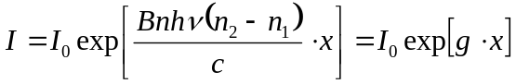
By considering intensity I₀ at some starting point. If that light travels once round the cavity then when it returns to its starting position then it will have changed to an amount 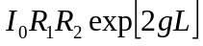 thus in one round trip the gain is 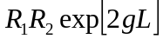.
For lasing we need a net gain duing this round trip, thus the gain in the material must overcome the losses in the mirrors. At threshold the gain equals the losses and we have: 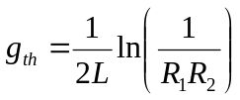
In reality there will be other losses due to light scattering in the laser material for example, or waveguide losses as we will see in a semiconductor laser. This gives us 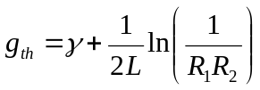
where is the loss per unit length in the laser waveguide or rod (or gas tube..)
The consequences of the above are:
The harder we can put energy into our laser material the better as then g will increase.
But of course this is an ideal: usually as we put more energy in the material gets hotter and the gain coefficient is temperature dependent.
The longer the laser rod then the easier it is to achieve threshold
Assuming you can make it, and also pump the rod uniformly!
The higher the mirror reflectivities the better
With the exception of semiconductor lasers the are usually very high (>90%)

Laser Modes
If light is bouncing back and forth in a cavity then it will form a standing wave. As for the quantum wells we discussed before this means that there are in this case discrete wavelengths which are allowed.
We can identify them from the standing wave condition: 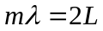
where m is a natural number and is the wavelength of the light in the material.
Thus the laser wavelength must be 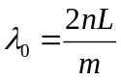
With the exception of one special case, which we will discuss later, usually 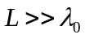 which means that the wavelength spacing between the allowed modes is small, given by 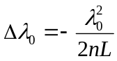
Homework show this for yourself!
Often the wavelength range over which we can get gain is large compared to the mode spacing, meaning the laser can laser on more than one mode at the same time. While for some special applications (Mode-Locking can be used to obtain very short powerful laser pulses), normally this is something we wish to avoid.

Laser Linewidth
Looking at a laser we can see that we have energy stored in a cavity and energy lost / sec. We can make as a result an empirical measurement of the linewidth of a laser mode:
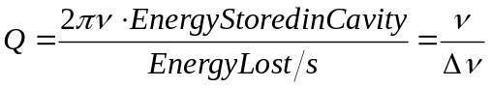
Let us assume mirrors of reflectivity, R, with no absorption in them.

The Energy Stored will be: 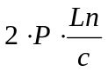. The Energy lost / second is: 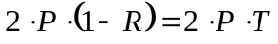
Hence 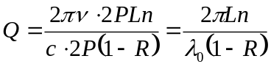.
For Large Q (and narrow linewidth) we want L large and R as close to 1 as possible.
In reality this simplistic model does not work (it sets only a upper limit, 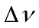). Amplification in the laser medium tends to sent Q towards infinity.
In an ideal laser the linewidth can be given by :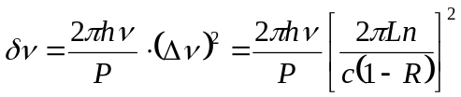
However due to practical limitations (vibrations, thermal fluctuations) this represents a lower limit for the linewidth. The key point here is that, as will be seen later semiconductor lasers tend to have small L and low R compared to other types so the laser linewidths are much larger than for other lasers.

Coherence Length
The potential narrow linewidth of a laser emission peak is key to many applications. For example in a communications system the fibre can have signals at many different wavelengths travelling down the fibre at once. In the ultimate limit the when the peaks neighbouring wavelengths overlap we can go no further. (In reality other factors are much more important however. Temperature changes the wavelength of operation of the laser slightly and these factors are dominant. In other experiments methods to measure extremely small shifts in the laser peak wavelength can be used to infer information about a system.
To consider coherence further let us first consider a photon emission from an “ordinary” source. In such a case the photon is essentially some form of wavepacket. We have a sine wave at the wavelength of the transition in the material in an envelope function, as shown on the left. We will take a more idealised analysis on the right where the sine wave is simple multiplied by and exponential decay given by the lifetime of the transition.

The functions will be
where , the lifetime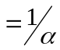
Taking the Fourier Transform we get 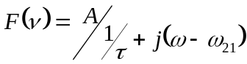
The intensity variation of the emission with frequency will be 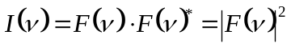
The function is as shown on the right
It is a LORENTZIAN where
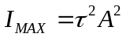
hence
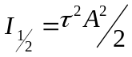
Substituting we can show that the linewidth
of the peak will is equal to 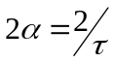
This means the longer the lifetime of the transition
the narrower the linewidth of the peak will be.
In a laser the fact that for a long time all the photons are identical and in particualar have the same phase means that the effective lifetime is very long. We can relate (let us say now) the experimentally observed linewidth, 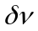to a time 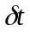where in essence this time is a measure of the length of time on average the beam remains coherent for, without the phase of the laser beam making a random jump, due to the vibrations or thermal fluctuations mentioned above.
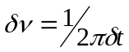. is known as the Coherence Time of the laser.
Knowing that in air the laser beam travels at the speed of light we can now get the Coherence Length:
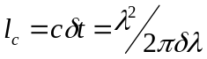 (assuming 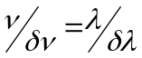, true if small)
A key application of this property is to let a beam interfere with itself, in a so-called interferometer. These are a good way of measuring tiny shifts in position of an object for example.

Spatial Coherence
Another useful property of a laser is that if you imagine a window through which the beam is being emitted, the photons from each part of that window are in phase.
This is completely different from say the surface of an LED, or a hot filament in a bulb, where the photons emitted at one part of the object have no phase relationship.
Consider the two images below. In the left example we have a spatially coherent source In the right image we have an incoherent source which can be treated as a series of point spots all emitting individually.

As a result, unlike an incoherent source which can only be focussed to another image of itself, a laser can be focussed to a tight spot limited only by the optical theory. This allows extremely high intensities to be reached, which a good for processing materials, or for focussing to a spot to detect a pit on a CD or DVD; but are bad for one’s eyes!

